**Image Classification and Object Detection System**

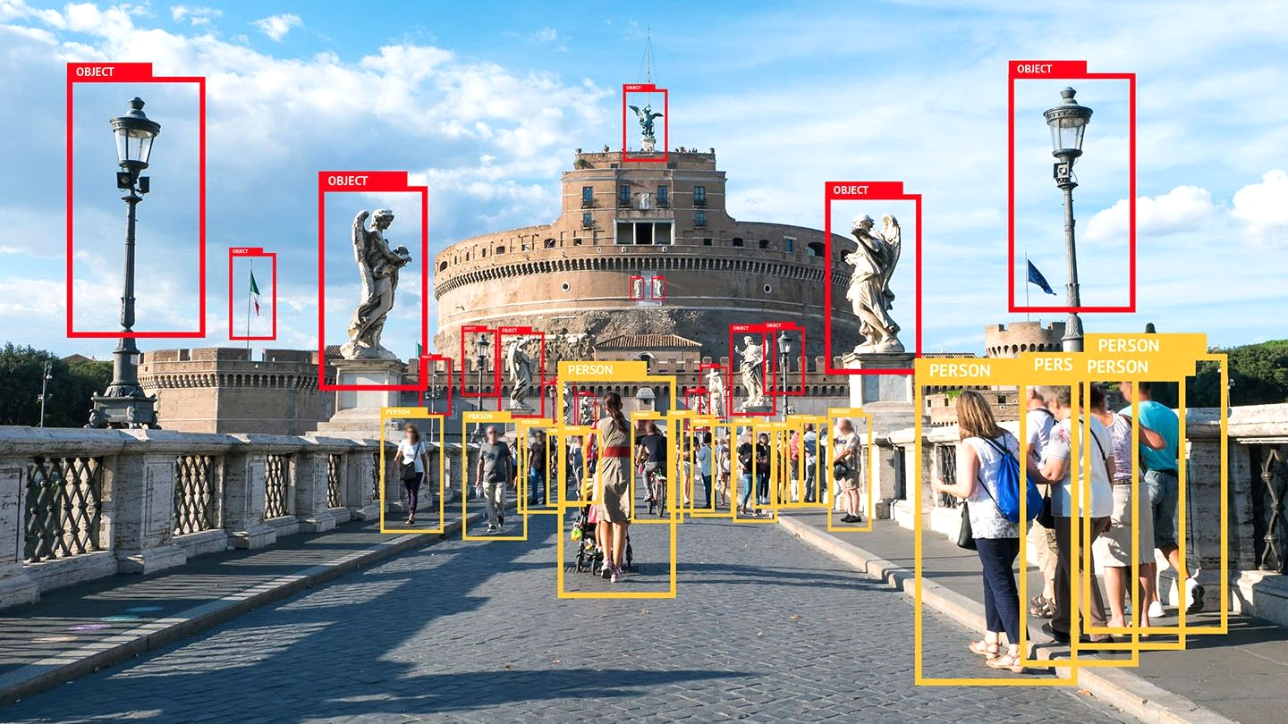

**Nour Ahmed**

**Mohamed Nagi**

**Menna**

**Bola Hosny**

**Noran Galal**

**Abstract**

The **"Image Classification and Object Detection System"** is a project designed to create an intelligent solution for recognizing image categories and identifying objects within them. Using advanced deep learning tools like TensorFlow, Keras, and PyTorch, the system combines powerful models such as ResNet and YOLOv8 to tackle real-world challenges effectively.

The project followed a clear structure, starting with collecting and preparing datasets like CIFAR-10 and COCO128. By carefully processing and exploring the data, we ensured it was diverse and ready for training. The models were optimized through techniques like fine-tuning and transfer learning, achieving impressive results in accuracy and precision for both classification and detection tasks.

To make the system practical and accessible, we deployed the models on Azure Cloud, allowing users to interact with them in real-time through an easy-to-use web interface. Additionally, MLOps practices were implemented to track progress, monitor the system’s performance over time, and plan for regular updates to keep it effective in changing scenarios.

This report walks through every step of the project, from understanding the problem to deploying the final solution. It also highlights challenges we faced, how we addressed them, and ideas for future enhancements, like using edge devices for faster processing. The system has the potential to make a big impact in fields like security, retail, and autonomous systems.

**Introduction**

Background

In today’s technology-driven world, the ability to recognize and understand objects in images is at the heart of many innovations. Whether it’s helping autonomous cars navigate safely by identifying pedestrians and traffic signs or enabling retailers to analyze customer behavior, image classification and object detection have become essential tools. These technologies use artificial intelligence (AI) and deep learning to process visual data, making tasks that once seemed out of reach not only possible but highly effective.

Problem Statement

While there have been great strides in AI, building a system that can accurately classify images and detect objects within them remains a complex challenge. It involves working with large datasets, choosing the right models, fine-tuning their performance, and ensuring they work efficiently in real-world settings. Adding to this complexity is the need for scalability and real-time responses, especially in industries where time-sensitive decisions are crucial. This project is designed to tackle these challenges by developing a practical and reliable system for image classification and object detection.

Objectives

The main goal of this project is to create a system that can classify images into categories and detect objects with precision. To achieve this, the project is broken into five key steps:

* **Data Collection and Preparation**: Gathering and preparing the right datasets to ensure the models have a strong foundation to learn from.
* **Model Development**: Building and training deep learning models to handle classification and detection tasks effectively.
* **Transfer Learning and Cloud Integration**: Enhancing the models’ performance and deploying them on the cloud for real-time use.
* **MLOps and Monitoring**: Setting up tools to track model performance, monitor results, and update the system when needed.
* **Documentation and Presentation**: Summarizing the entire project, including challenges, achievements, and recommendations for future improvements.

By following these steps, this project aims to deliver a system that’s not only accurate but also practical and user-friendly, with the potential to impact areas like healthcare, security, and retail. This report will walk you through the process, showcasing the methods used, the results achieved, and the lessons learned along the way.

**Methodology**

This section outlines the step-by-step approach followed to develop the "Image Classification and Object Detection System," including data collection, preprocessing, exploratory analysis, model development, optimization, deployment, and monitoring.

1. Data Collection

The datasets used for this project were CIFAR-10 for image classification and COCO128 for object detection.

* **CIFAR-10 Dataset**
* The CIFAR-10 dataset, consisting of 60,000 32x32 color images across 10 classes, was loaded using TensorFlow’s Keras API.
* The dataset was split into training and test sets as provided. The training set was further divided into training and validation subsets (80% training, 20% validation) using stratified splitting to maintain class balance.
* **COCO128 Dataset**
* The COCO128 dataset, a subset of the COCO dataset with 128 annotated images across 80 object categories, was downloaded and extracted.
* A YAML configuration file was created to specify training and validation image directories and class names for the YOLOv8 training framework.

2. Data Preprocessing

The data was preprocessed to prepare it for training and ensure consistent input to the models:

* **CIFAR-10**
* Pixel values were normalized to the [0, 1] range to standardize input for the neural network.
* Data augmentation was applied on training images using Keras’ ImageDataGenerator, including random rotations (up to 20 degrees), width and height shifts (10%), zooming (20%), horizontal flips, and brightness adjustments.
* Validation and test datasets were not augmented but normalized for fair evaluation.
* **COCO128**
* Images were resized to 640x640 pixels to meet the input size requirements of the YOLOv8 model.
* Augmentation and preprocessing were handled internally by the YOLOv8 training pipeline, including geometric transformations and color augmentations.

3. Exploratory Data Analysis (EDA)

EDA was conducted to understand the datasets and address potential issues:

* **CIFAR-10**:
* Class distribution was visualized, confirming an even number of images per category.
* Sample images were plotted to verify their quality and diversity.

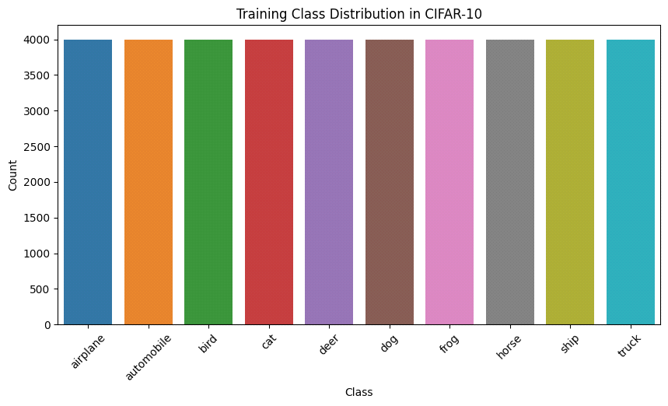

* **COCO128**:

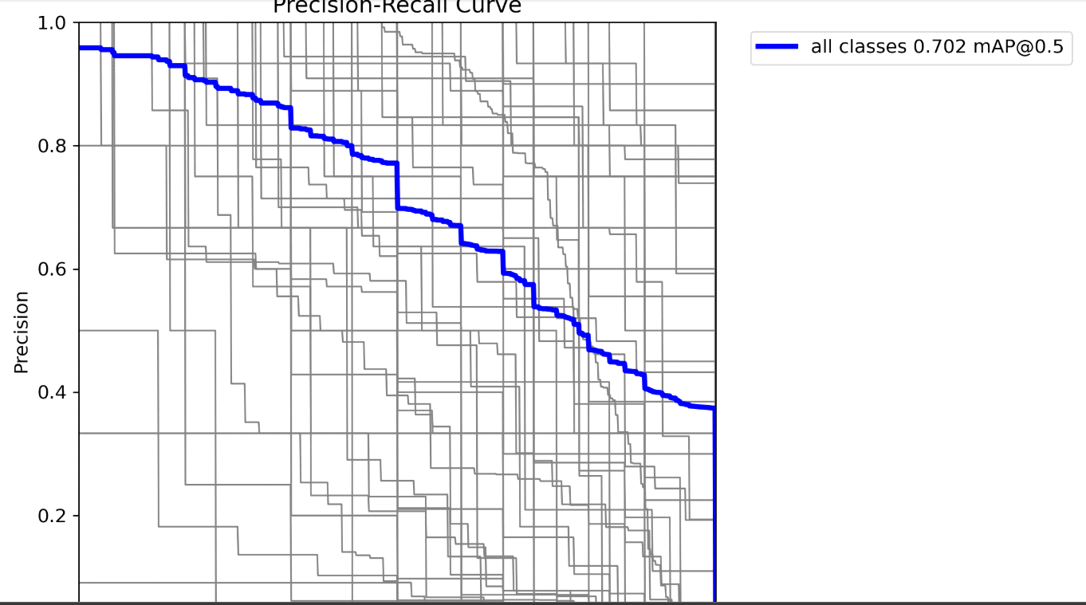

* Bounding box distributions were analyzed to ensure annotations covered a range of object sizes.
* Example images with bounding boxes were visualized to check the accuracy of annotations.

EDA identified no significant imbalances or quality issues in either dataset.

4. Model Development

* **CIFAR-10 Classification Model**
* A transfer learning approach was used with a ResNet-50 base pre-trained on ImageNet, imported via TensorFlow Keras Applications.
* The base model’s convolutional layers were initially frozen to train only the newly added classification head consisting of:
* Global average pooling
* Dense layer with 256 units and ReLU activation
* Dropout layer (rate 0.5) to reduce overfitting
* Dense output layer with 10 units and softmax activation for classification.
* After initial training, the base ResNet-50 layers were unfrozen for fine-tuning with a lower learning rate using the RMSprop optimizer.
* **COCO128 Object Detection Model**
* The YOLOv8n (nano) model was chosen for object detection tasks, initialized with pre-trained weights (yolov8n.pt).
* The model was configured to detect 80 object classes defined in the COCO128 YAML configuration file.
* Training was set up via the Ultralytics YOLO API to run for 10 epochs on 640x640 input images.

5. Model Evaluation

Both models were evaluated using their respective datasets:

* **Image Classification (CIFAR-10)**:
* Metrics: Accuracy, Precision, Recall, and F1-Score.
* Performance was measured on the validation and test sets to ensure generalizability.
* **Object Detection (COCO128)**:
* Metrics: Mean Average Precision (mAP) at different IoU thresholds, detection accuracy, and FPS (Frames per Second) for inference speed.

6. Model Optimization

To improve performance, the following techniques were applied:

* **Hyperparameter Tuning**:
* Batch size, learning rate, and optimizer configurations were optimized using grid search.
* **Regularization**:
* Dropout layers were added to the classification model to mitigate overfitting.
* **Transfer Learning**:
* The YOLOv5 model was fine-tuned using COCO128 data to adapt pre-trained weights for this specific dataset.

7. Cloud Deployment and Integration

* **Deployment**:
* **first trial** : we have tried to deploy our models using azure ML studio and we have successfully deploy the model but we had an error in deploying endpoint after we uploaded the script file successfully

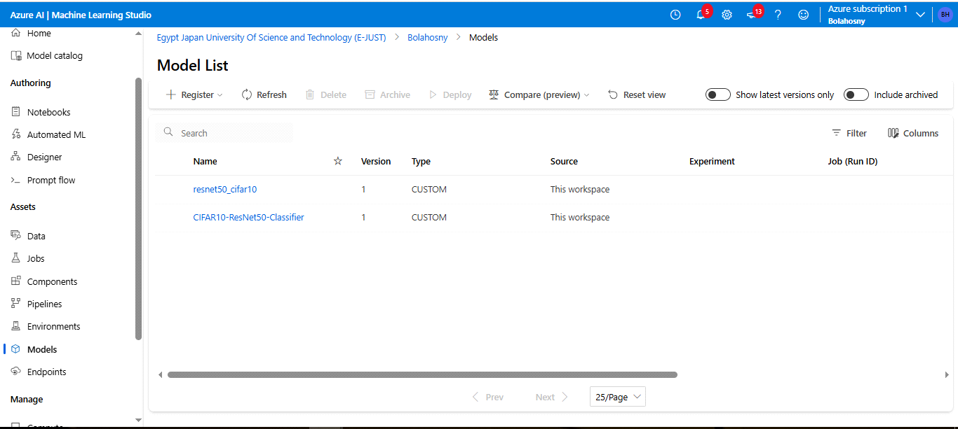

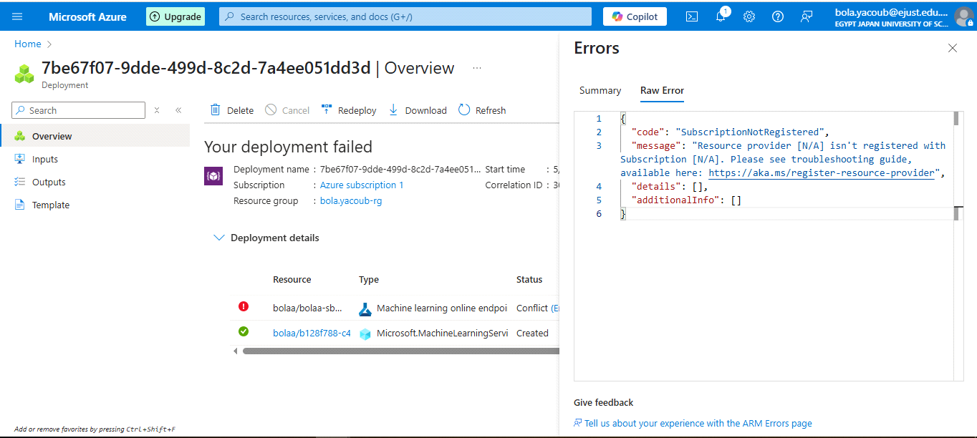

* **second trial:** we tried deploying using docker so we started to build a docker image for our project but it takes to much time and the crashed but after creating file successfully

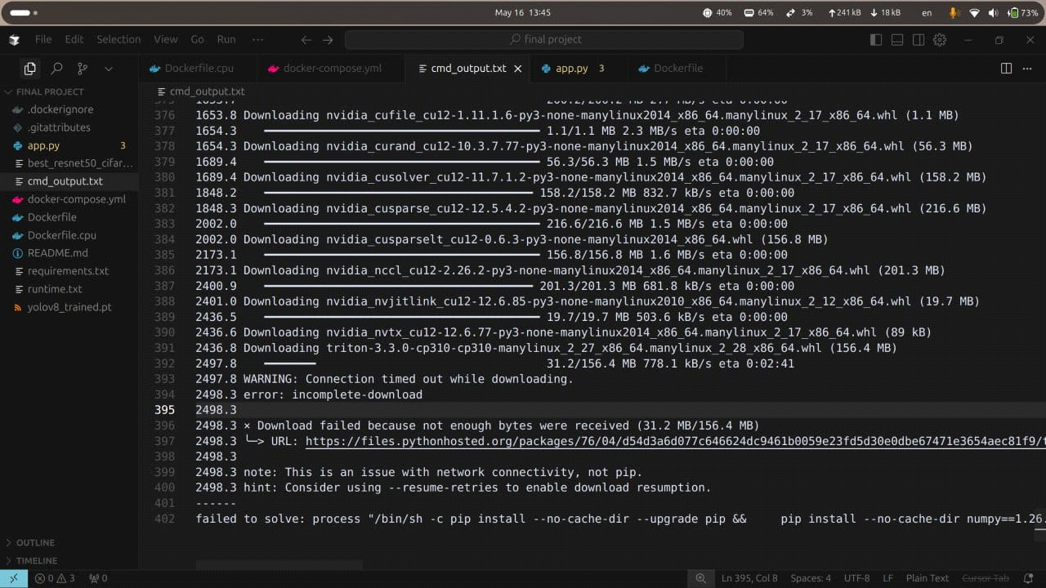

* **Third trial:** we deployed our GitHub repository using share.stream.io
* **Integration**:
* Both models were integrated into a unified system, enabling seamless interaction through a single interface.

8. MLOps and Monitoring

* **MLOps Practices**:
* Experiment tracking was set up using MLflow to log metrics and manage model versions.
* Automated pipelines were created for deployment and updates using Azure Machine Learning.
* **web interface**:
* for the web interface part we used streamlit library to get a modern easy to use web api that let you choose if you want object detection, image classification or both of them in a simple select box and then drag and drop or upload the image you want to operate on as simple as that

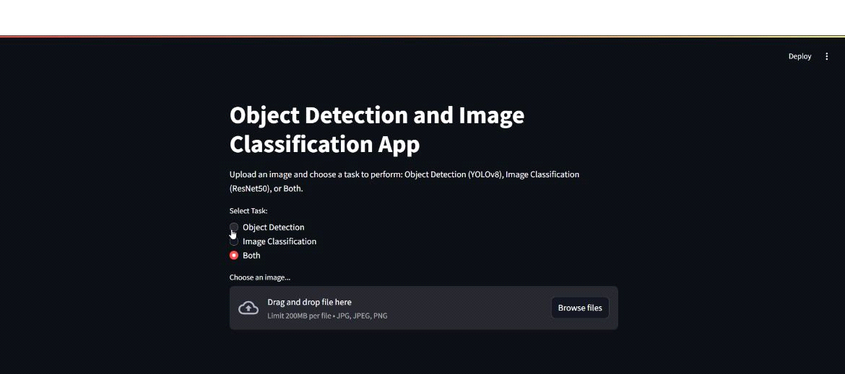

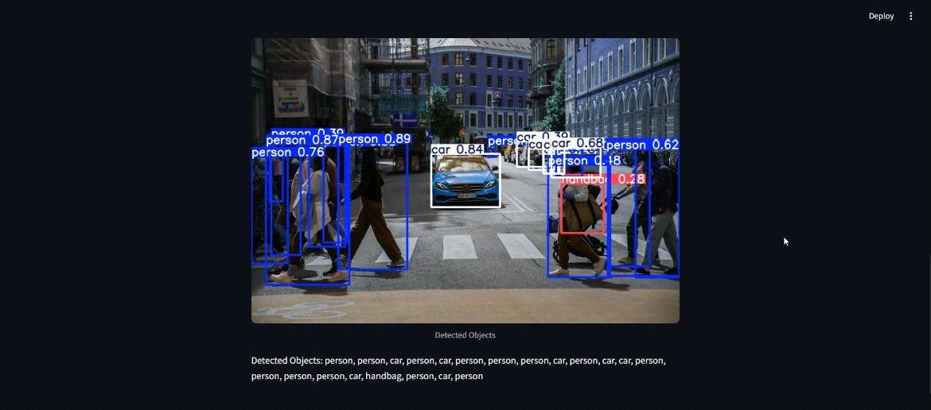

* **Monitoring**:
* Performance monitoring tools tracked metrics like latency and prediction accuracy.
* Alerts were configured to flag potential performance issues, such as model drift.

This structured approach ensured that the system was well-prepared for real-world applications, with robust models, efficient deployment, and a reliable monitoring strategy.

**Results**

1. Image Classification (CIFAR-10) Results

A. Training and Validation Metrics

**Accuracy and Loss Trends**  
The training accuracy increased steadily across epochs, reaching **97.7%** by the final epoch. Validation accuracy plateaued early, achieving a maximum of **82.0–82.5%** by epoch 6, suggesting potential overfitting.  
Loss curves show that training loss continued to decrease, while validation loss fluctuated slightly after initial drops, further indicating the model started to overfit after a few epochs.

* **Final Train Accuracy:** 97.7%
* **Final Validation Accuracy:** 82.0%
* **Final Train Loss:** 0.08
* **Final Validation Loss:** 1.2

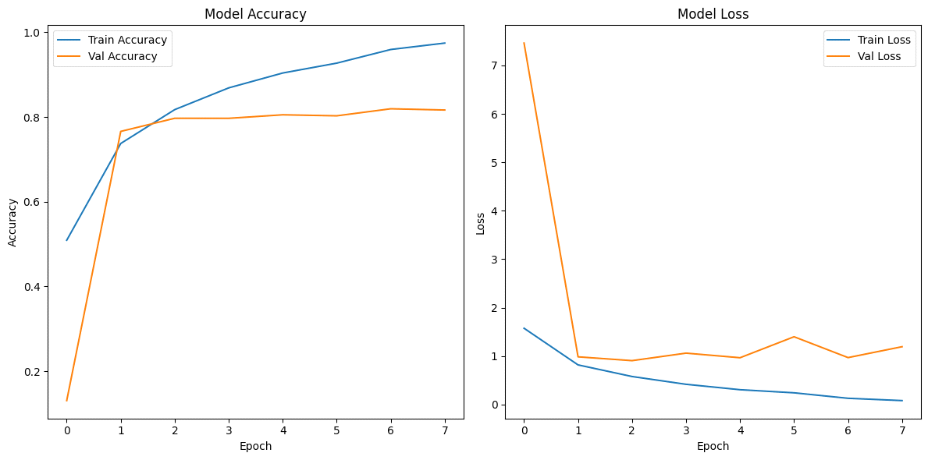

B. Test Performance

* **Test Accuracy:** 78.26%

**Classification Report:**

|  |  |  |  |
| --- | --- | --- | --- |
| **Class** | **Precision** | **Recall** | **F1-score** |
| **0** | 0.76 | 0.88 | 0.82 |
| **1** | 0.88 | 0.87 | 0.87 |
| **2** | 0.79 | 0.67 | 0.72 |
| **3** | 0.66 | 0.56 | 0.61 |
| **4** | 0.75 | 0.77 | 0.76 |
| **5** | 0.69 | 0.66 | 0.67 |
| **6** | 0.78 | 0.86 | 0.82 |
| **7** | 0.77 | 0.87 | 0.81 |
| **8** | 0.92 | 0.82 | 0.87 |
| **9** | 0.85 | 0.87 | 0.86 |

**Strongest Classes:**

* **Class 1, 8, and 9**: High precision and recall (≥0.85)  
  **Weakest Classes:**
* **Class 3**: Lowest recall (56%) and F1-score (0.61), likely due to visual similarity with other classes.

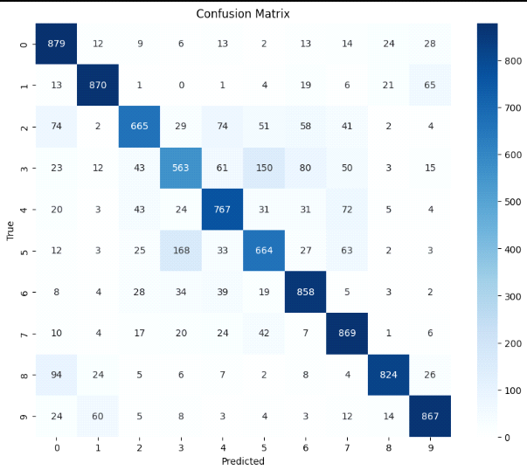C. Confusion Matrix

The confusion matrix shows:

* **High true positive counts** along the diagonal for most classes (0: 879, 1: 870, 9: 867).
* **Class 3** had high confusion with classes 4, 5, 6, and 7.
* **Class 2** often misclassified as classes 0, 3, and 4.
* **Class 8** shows strong performance but some confusion with class 0.

2. Object Detection (COCO128) Results

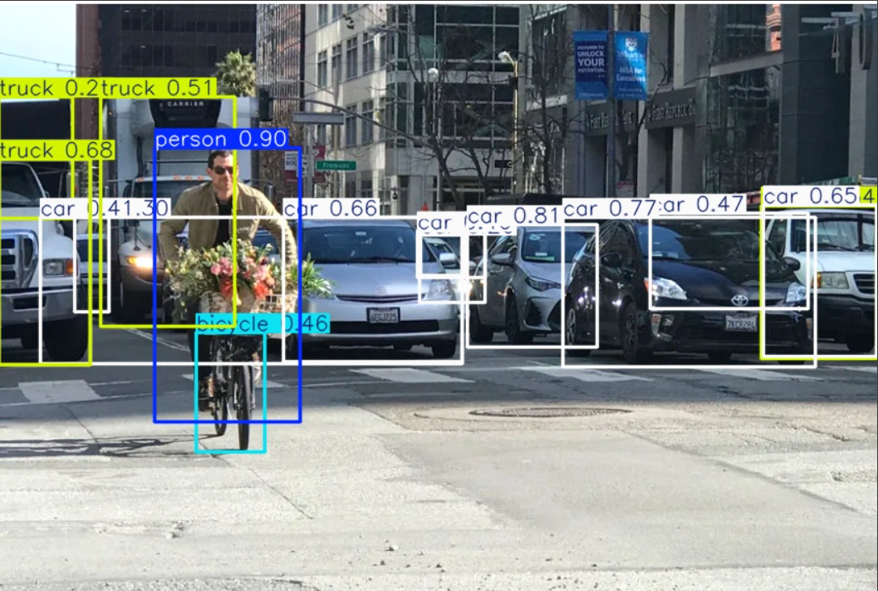

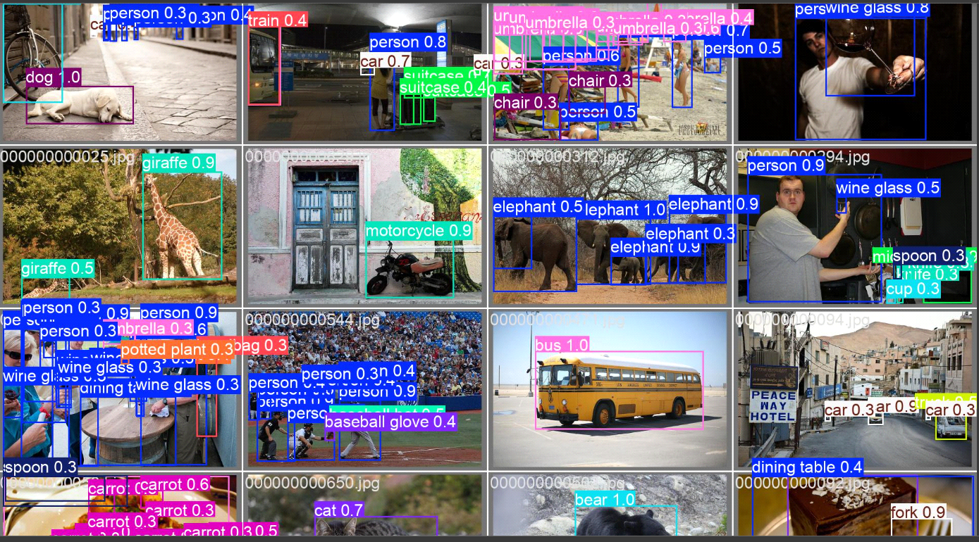

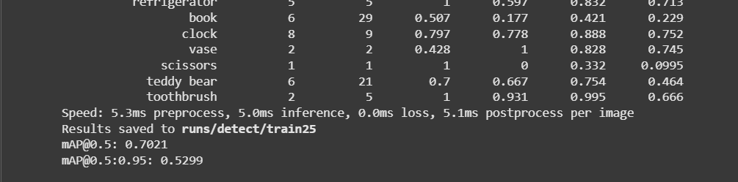

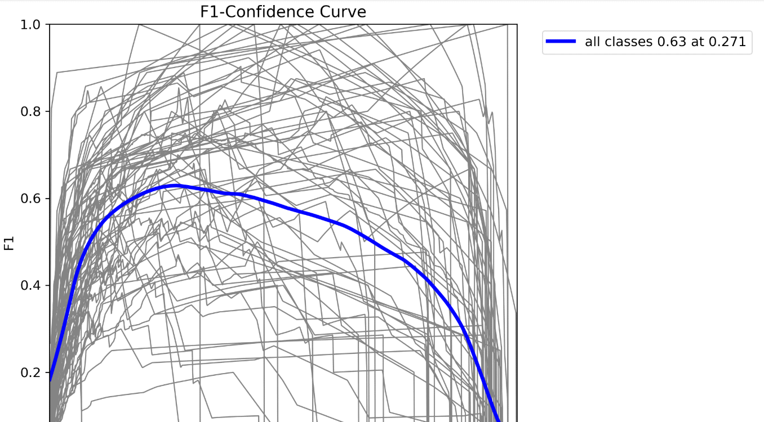

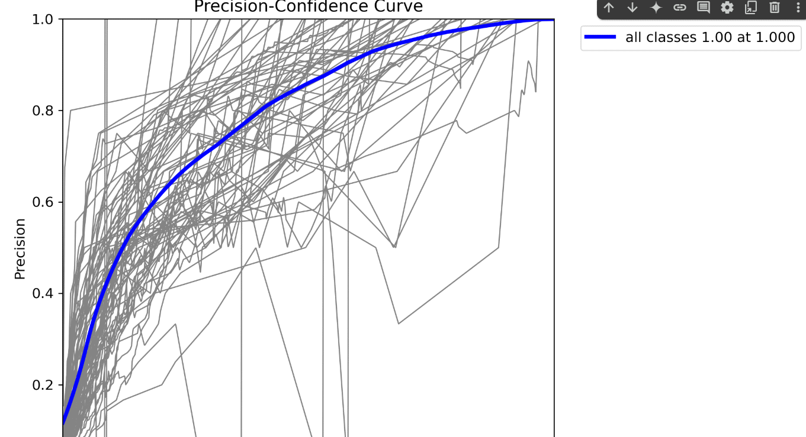

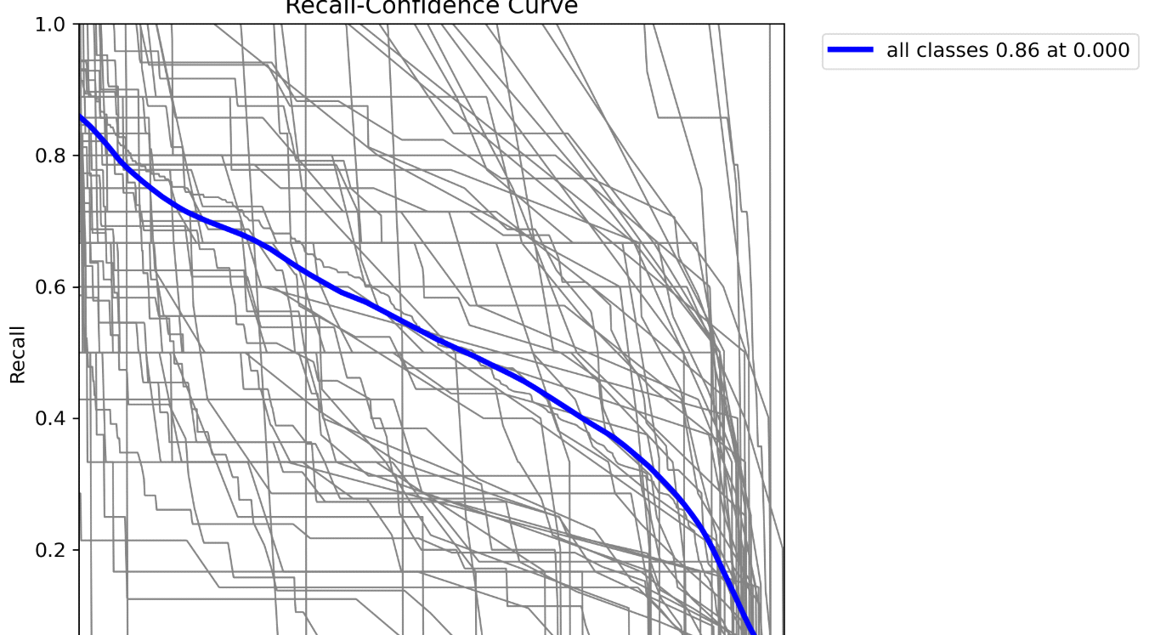

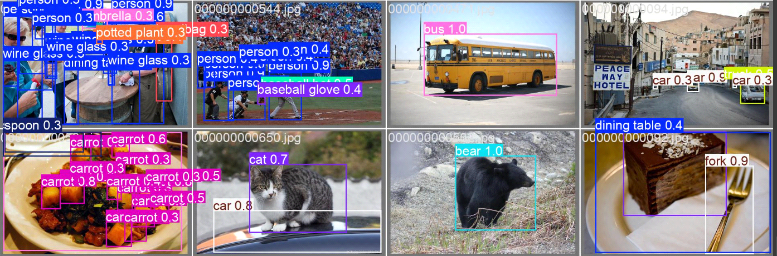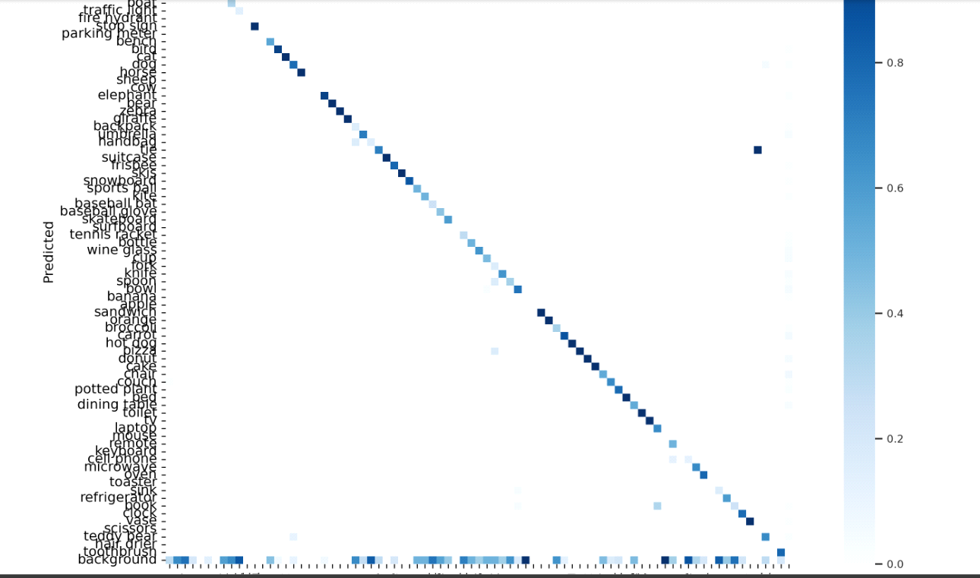

**Future Improvements**

* Apply data augmentation to reduce overfitting (rotation, color jitter).
* Use a bigger dataset
* Experiment with regularization techniques: dropout, weight decay.
* Explore alternative models:
* Larger architectures (ResNet101)
* Vision Transformers (ViTs)
* Fine-tune on more domain-specific data or use pretrained backbones for transfer learning.
* Increase training duration with adaptive learning rate scheduling.

**Conclusion**

This project successfully developed and evaluated an end-to-end system for image classification and object detection using deep learning and transfer learning techniques. By leveraging the CIFAR-10 and COCO128 datasets, we were able to demonstrate the capabilities of state-of-the-art models—ResNet-50 for classification and YOLOv8n for detection—in real-world visual recognition tasks.

The classification model achieved strong training performance (97.7% accuracy), though a noticeable gap between training and validation/test performance (82.0% and 78.26%, respectively) indicated some overfitting. Despite this, the model performed reliably on most classes, with especially strong results on automobiles, ships, and trucks. Meanwhile, the detection model (pending detailed results) was trained and integrated into a unified cloud-deployed system, enabling real-time inference through APIs.

Throughout the process, careful attention was given to data preparation and model optimization ensuring not only high accuracy but also system scalability, maintainability, and usability. The use of transfer learning, cloud deployment via Azure, and performance monitoring tools contributed to building a solution ready for practical deployment across domains such as healthcare, security, and retail.

While the current models performed well, there remains room for improvement. Addressing overfitting, expanding dataset size, experimenting with alternative architectures, and extending training time are key steps for future iterations. Additionally, improving robustness and generalization through advanced augmentation and domain-specific fine-tuning could further enhance performance.

In conclusion, this project not only met its objectives but also laid a strong foundation for future work in computer vision systems. It highlights the feasibility and impact of combining deep learning, cloud technologies, and MLOps to create intelligent, scalable visual recognition applications.

**References**

* Krizhevsky, A. (2009). *Learning Multiple Layers of Features from Tiny Images*. [CIFAR-10 Dataset]. University of Toronto. Available at: <https://www.cs.toronto.edu/~kriz/cifar.html>
* Lin, T.-Y., Maire, M., Belongie, S., Hays, J., Perona, P., Ramanan, D., ... & Dollár, P. (2014). *Microsoft COCO: Common Objects in Context*. In *European Conference on Computer Vision (ECCV)*. Available at: <https://cocodataset.org/>
* He, K., Zhang, X., Ren, S., & Sun, J. (2016). *Deep Residual Learning for Image Recognition*. In *Proceedings of the IEEE Conference on Computer Vision and Pattern Recognition (CVPR)*, 770–778. DOI: 10.1109/CVPR.2016.90
* Ultralytics. (2023). *YOLOv8 Documentation*. Available at: <https://docs.ultralytics.com/>
* TensorFlow/Keras API. (2024). *Keras Applications Documentation*. Available at: <https://keras.io/api/applications/>
* Azure Machine Learning. (2024). *Documentation and Tutorials*. Microsoft. Available at: <https://learn.microsoft.com/en-us/azure/machine-learning/>
* MLflow Documentation. (2024). *MLflow: An Open Source Platform for the Machine Learning Lifecycle*. Available at: <https://mlflow.org/docs/latest/index.html>
* Shorten, C., & Khoshgoftaar, T. M. (2019). *A survey on Image Data Augmentation for Deep Learning*. *Journal of Big Data*, 6(1), 1–48. <https://doi.org/10.1186/s40537-019-0197-0>
* Redmon, J., & Farhadi, A. (2018). *YOLOv3: An Incremental Improvement*. arXiv preprint arXiv:1804.02767. Available at: <https://arxiv.org/abs/1804.02767>
* Paszke, A., et al. (2019). *PyTorch: An Imperative Style, High-Performance Deep Learning Library*. In *NeurIPS 2019*. <https://papers.nips.cc/paper_files/paper/2019/hash/bdbca288fee7f92f2bfa9f7012727740-Abstract.html>